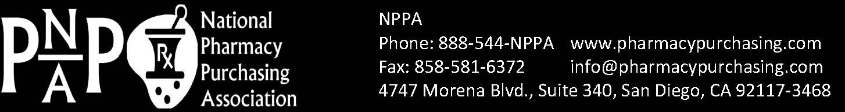

Pharmacy Buyer Day
Friday, October 21, 2022

A Proclamation by NPPA, the
National Pharmacy Purchasing Association

Whereas, Pharmacy Buyers are employed by both institutional Health Care and retail pharmacies, as liaisons between the Art of Pharmacy and the Business of Pharmacy;

Whereas, Pharmacy Buyers are employed to contribute their part for the health and welfare of the public by contributing to the health and welfare of the Health Care facilities for which they serve, through procuring prudent pharmaceuticals and pharmaceutical-related purchases;

Whereas, Pharmacy Buyers are charged with procuring prudent pharmaceuticals and pharmaceutical-related products from reliable and trusted sources, so as to not endanger the public;

Whereas, Pharmacy Buyers are charged with procuring prudent pharmaceuticals and pharmaceutical-related products at the best cost to their Health Care facilities and at the highest quality;

Whereas Pharmacy Buyers are an integral part of the Health Care Team, providing their knowledge, training and experience in the interest of Public Safety and Organizational Fiduciary;

THEREFORE I, NPPA Member <ADD YOUR NAME/FACILITY+CHANGE TO BLACK>,
Do hereby proclaim Friday, the 21st day in October in the Year 2022 as:

“Pharmacy Buyer Day”

And calls upon the community and partner organizations to celebrate
With appropriate ceremonies to acknowledge these efforts.

Visit NPPA online, at: www.PharmacyPurchasing.com
Phone: 888-544-NPPA  Fax: 858-581-6372

